
GDC64 Tablet Aircraft Interface Unit (TAIU)
• 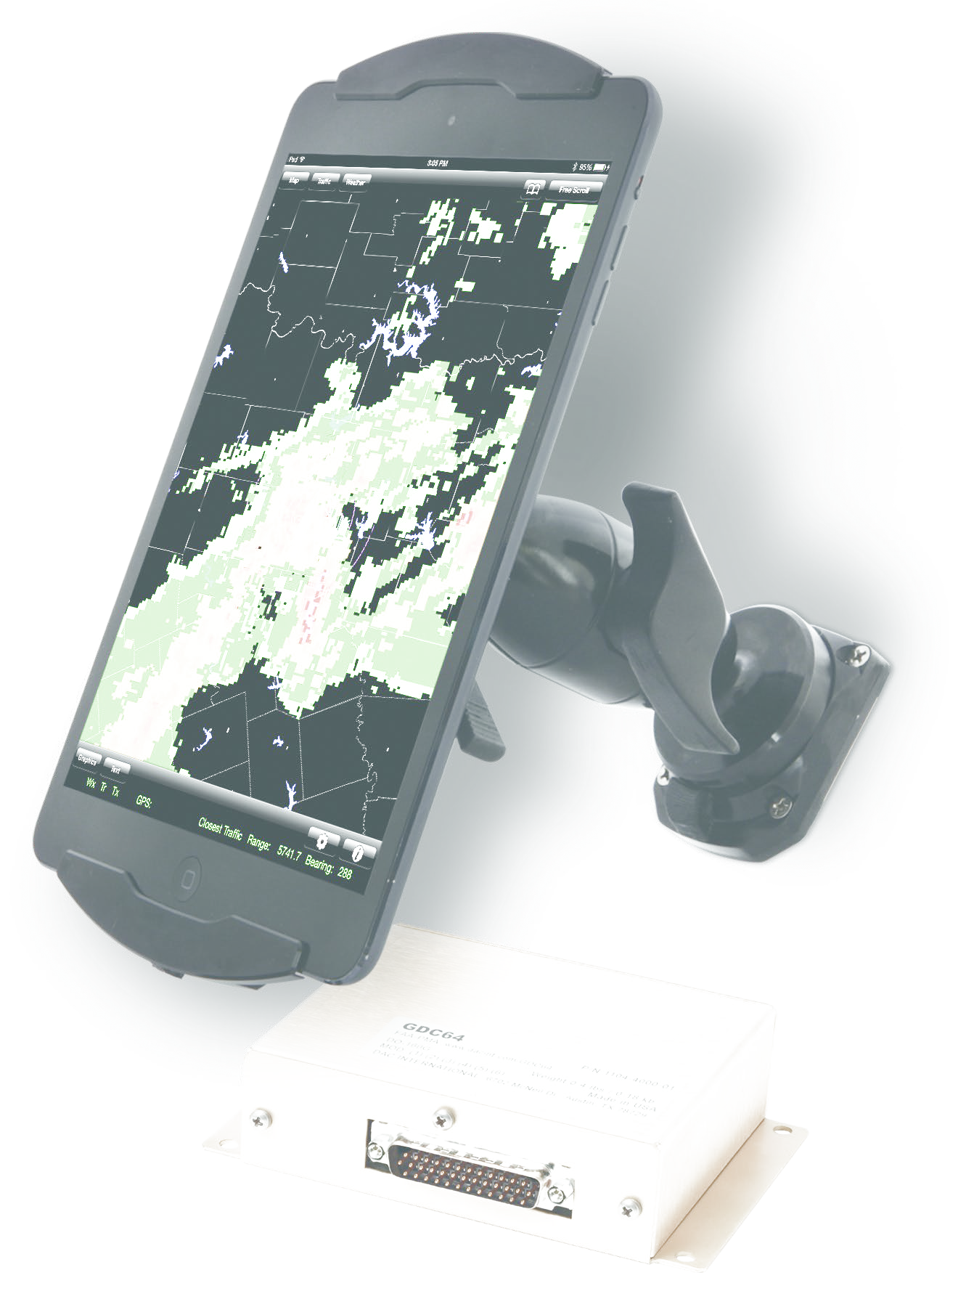
- Appr
- F
•
- Pr •
•
even mor
•
the iPad.
- W
air
•

DAC International
6702 McNeil Drive, Austin, Texas 78729 P. 800.527.2531 (U.S. only) | 512.331.5323 F: 512.331.4516 dacinfo@dacint.com | www.dacint.com
Typical features of GDC64:
- • • •
Operational aspects 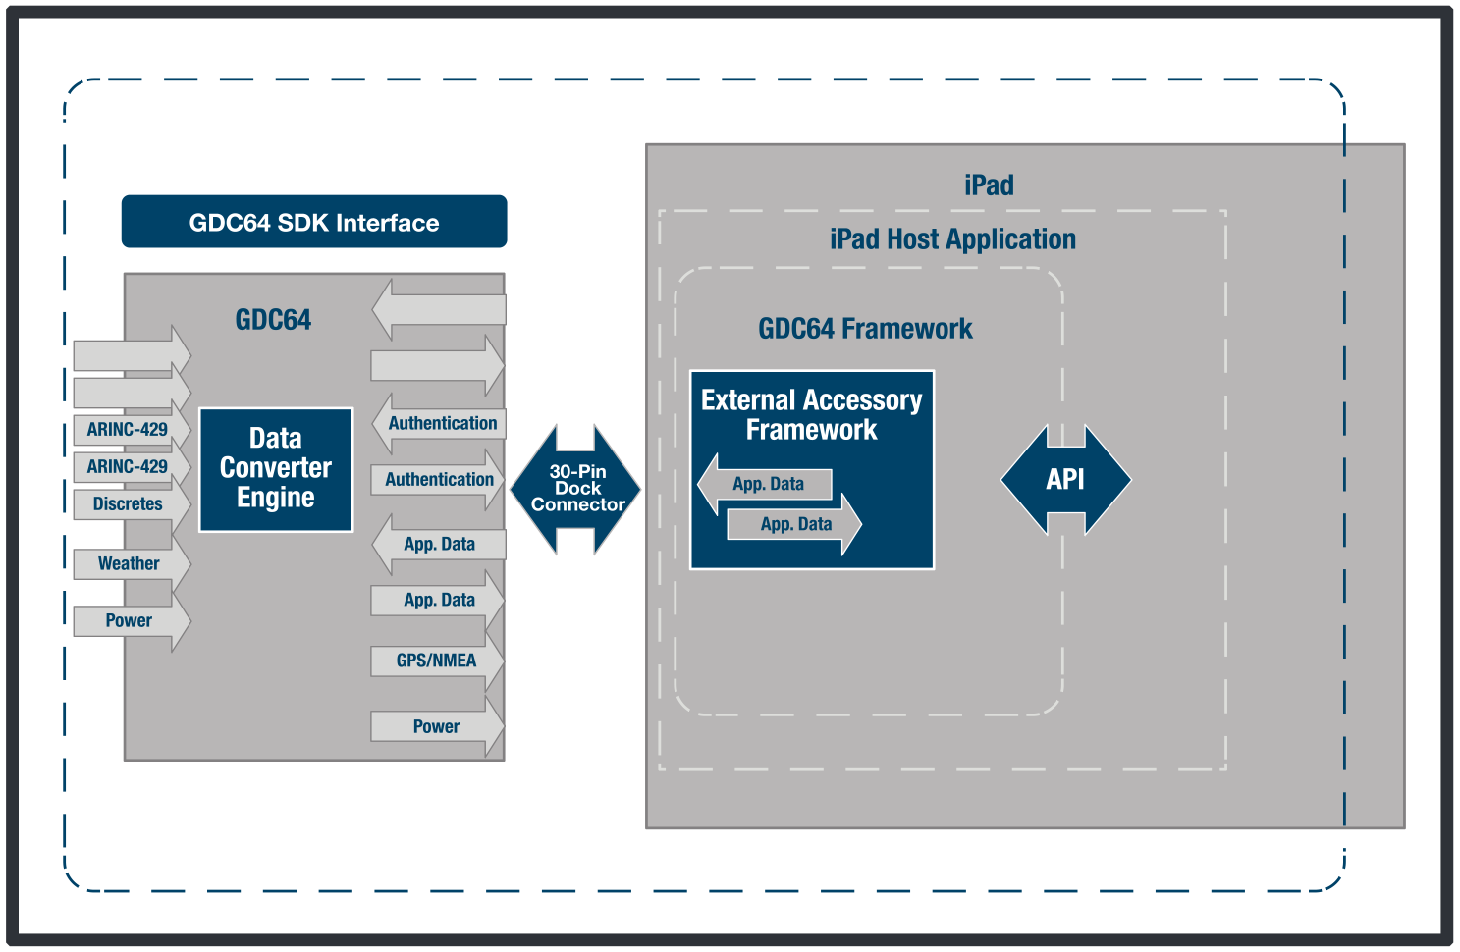•

Software Development Kit

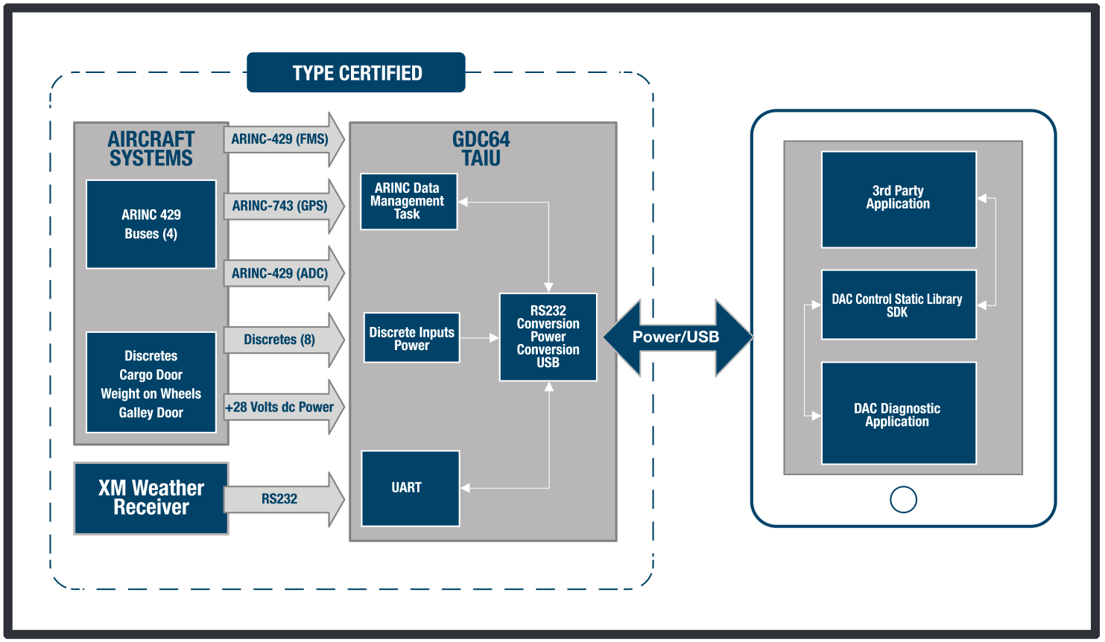

Apple MFi licensee
Included with the GDC64: As prescribed in 47.103-2 , insert the following clause: Submission of Transportation Documents for Audit (Feb 2006) (a) The Contractor shall submit to the address identified below, for prepayment audit, transportation documents on which the United States will assume freight charges that were paid-
(1) By the Contractor under a cost-reimbursement contract; and
(2) By a first-tier subcontractor under a cost-reimbursement subcontract thereunder.
(b) Cost-reimbursement Contractors shall only submit for audit those bills of lading with freight shipment charges exceeding $100. Bills under $100 shall be retained on-site by the Contractor and made available for on-site audits. This exception only applies to freight shipment bills and is not intended to apply to bills and invoices for any other transportation services.
(c) Contractors shall submit the above referenced transportation documents to- ________________________________________________ ________________________________________________ ________________________________________________ [ To be filled in by Contracting Officer ] (End of clause)

