POP-UP VIDEO DOES NOT DOWNLOAD
DOC-456
Department Owner: Just Pretend  FedEx Ground and FedEx Ground, Ltd. | Last Update: 28 February 2023 DRAFT

Overview
Provide a description and purpose of the material covered in the document. This section is REQUIRED

Issues
Required Video - when I click play on the pop-up video it just keeps trying to load (as shown below). If I click Turn Video Off – then the entire course plays with no video at all (not just the pop up videos). I’ve tried this I believe 4 times now – I even restarted my computer. Please assist or just give me credit.
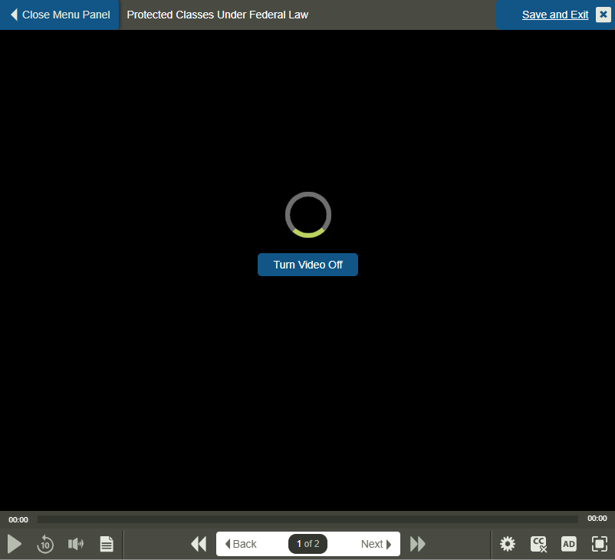

Related Documents
Further information is located in the documents listed below.

Policies:
Link to policy(-ies) (governing policy)

Online Manuals and Forms Materials:
Link to material published to OM&F

Other Materials:
- Material housed in the warehouse or published to other sites (links are permissible to other sites if requested by owning department)

